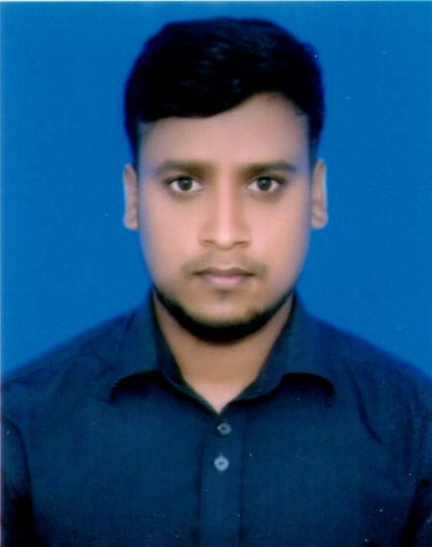

Md.Sanoar Hosin

Email: sanoar2015.sp@gmail.com

Mobile: 01750933711.

PERSONAL PROFILE

I feel that I am hardworking, energetic, technically astute and work well independently and within a team. I possess good communication skills both verbal and written and always strive to meet deadlines.

OBJECTIVE

To work in a professional environment for getting the opportunity to utilize my knowledge, creativity as well as educational experiences to attain the organizational goal and to build up my career in the field of business and commercial sector.

EDUCATION AND QUALIFICATIONS

Recent Education Status:

Bachelor of Science
Department Of Geography & Environment
CGPA-3.18(out of 4)
Govt. Shah Abdur Rouf College.

HSC

From Business Studies group in 2013. Obtained GPA- 4.30 (out of 5) Boirati degree College,Mithapukur,Rangpur.

SSC

From Business Studies in 2011. Obtained GPA- 4.25(out of 5), Imadpur High School,Mithapukur,Rangpur.
ADDITIONAL SKILLS

➢ Communication skill : Proficient both verbal and written communication in English & Bengali
- [

➢ Computer skill : Proficient in Ms Office applications (Ms Excel, Ms Word, PowerPoint, Ms Outlook) and internet.
PERSONAL INFORMATION

➢ Father’s name : Md. Mijanur Rahman
- Mother’s name : Mst. Salma Begum
➢ | Date of Birth | : | 25/11/1996
➢ | Gender | : | Male
➢ Nationality |  | : | Bangladeshi
➢ Marital Status |  | : | Married
➢ Languages |  | : | Bengali, English, Hindi
➢ Religious |  | : | Islam
➢ Permanent address |  | : Vill:Sarkar para, P.O:Boiratihat, Upz: Mithapukur
 |  |  | Dist: Rangpur.

LEISURE INTERESTS

- Social networking & Activities.

- Cricket, football.

- Surfing internet

- Travelling.
- Support Poor People

REFERENCE

Md Hasan Imam Shamim

Md Sazzad Hossain

Professor

Assistant professor

Boirati Degree College.

Rangpur govt college,Rangpur.

  01705837669  01718532969

DECLARATION

I do hereby declare that the particulars of information and facts stated here in above are true, correct and complete to the best of my knowledge and belief.

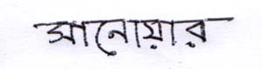

Sanoar Hosin

